“Advancing Optimization Efficiency with Parallelized Genetic Algorithms”



Author:

JAI SAXENA

Student ID: 02129249

University of Massachusetts, Dartmouth

**INTRODUCTION**:

1. Genetic algorithms are search and optimization algorithms inspired by the process of natural selection and genetics. They are used to find approximate solutions to optimization problems.
2. Genetic algorithm (GA) is one of the most popular stochastic optimization algorithms often used to solve complex large-scale optimization problems in various fields.
3. Genetic Algorithms (GAs) emulate the process of natural selection to solve complex optimization problems.
4. Parallelizing GAs leverages multiple cores, aiming to expedite the convergence of solutions.

**PURPOSE & SIGNIFICANCE**

**Purpose**: This study investigates the impact of parallelization on Genetic Algorithms by examining execution times across different core counts, aiming to enhance the efficiency of optimization processes.

**Significance**: Optimization problems are prevalent in various fields, demanding efficient solutions. Parallelizing GAs could potentially offer substantial time savings and resource optimization.

**Relevance**: In the era of multi-core processors, harnessing parallel computing capabilities becomes pivotal. Understanding the relationship between core counts and performance aids in optimizing algorithms for speed and efficiency.

**APPLICATIONS OF GENETIC ALGORITHMS**

1. **Engineering Design**: Genetic algorithms can be used to optimize parameters in engineering design problems, such as finding the optimal shape of an airplane wing.
2. **Data Mining**: Genetic algorithms can be applied to data mining tasks, such as feature selection and clustering.
3. **Robotics**: Genetic algorithms can be used to optimize the control parameters of robots, such as finding the optimal gait for a walking robot.

**HYPOTHESIS, METHODS, AND TERMINOLOGIES**

**Hypothesis**: The hypothesis section states the anticipated outcome or expected relationship that the study aims to verify or refute. The hypothesis posits a direct correlation between increased core counts and reduced execution times in GAs. It anticipates a linear relationship where more cores lead to faster convergence, reflecting the study's anticipated results.

**Methods**: The methods section details the approach, tools, and techniques employed to conduct the study or experiment. This segment elaborates on the utilization of MATLAB's Parallel Computing Toolbox to implement the GA. It emphasizes the GA's structure, encompassing selection, crossover, and mutation operations across multiple generations.

**Terminologies**:  The algorithms and terminologies section clarifies the foundational concepts and specialized terms relevant to the study. This part delves into the specifics of GAs, elucidating concepts like

1. Populations (sets of potential solutions),
2. Fitness Functions (evaluating solution quality), and
3. Genetic Operations (selection, crossover, and mutation) employed in GAs.

**PARALLELIZATION TECHNIQUES**

* **Multithreading:** Multithreading involves dividing the genetic algorithm into multiple threads, each of which can be executed concurrently. This allows for parallel processing within a single machine, improving optimization efficiency.
* **Distributed Computing:** Distributed computing involves running multiple instances of the genetic algorithm on different machines or processors. This allows for parallel execution and can significantly reduce the optimization time.

For my work, **Distributed computing** has been used as tasks are distributed among multiple computational nodes or workers for parallel processing across different core counts. Have used core counts 2, 4, 6, 8, 10, 12 for my work.

**APPENDIX A: CODE**

% Defines fitness function here

fitnessFunction = @(x) sum(x.^2); % Example fitness function (minimize sum of squares)

% Defines genetic algorithm options

options = gaoptimset('UseParallel', true, 'Display', 'off'); % Enables parallel computing

% Defines problem and GA parameters

nVar = 10; % Number of variables in the optimization problem

lb = -10 * ones(1, nVar); % Lower bounds for variables

ub = 10 * ones(1, nVar); % Upper bounds for variables

% Runs parallelized genetic algorithm for different core counts

coresToTest = [2, 4, 6, 8, 10, 12]; % Cores to test

timeTaken = zeros(size(coresToTest)); % Array to store execution times

for i = 1:length(coresToTest)

numCores = coresToTest(i);

% Checks if there's an existing pool and delete it before creating a new one

existingPool = gcp('nocreate');

if ~isempty(existingPool)

delete(existingPool);

end

% Runs the genetic algorithm without explicitly setting parallel pool

options = gaoptimset(options, 'UseParallel', true, 'Display', 'off');

% Runs the genetic algorithm

tic;

[~, ~] = ga(fitnessFunction, nVar, [], [], [], [], lb, ub, [], options);

timeTaken(i) = toc;

end

% Displays the execution times

disp('Execution times for different core counts:');

disp(timeTaken);

% Visualizes the execution times against core counts

figure;

plot(coresToTest, timeTaken, 'bo-', 'LineWidth', 2);

xlabel('Number of Cores');

ylabel('Execution Time (seconds)');

title('Execution Time vs Number of Cores');

grid on;

**APPENDIX B: RESULTS AND ANALYSIS**

**Output:**

Parallel pool using the 'Processes' profile is shutting down.

Starting parallel pool (parpool) using the 'Processes' profile ...

Connected to parallel pool with 6 workers.

Parallel pool using the 'Processes' profile is shutting down.

Starting parallel pool (parpool) using the 'Processes' profile ...

Connected to parallel pool with 6 workers.

Parallel pool using the 'Processes' profile is shutting down.

Starting parallel pool (parpool) using the 'Processes' profile ...

Connected to parallel pool with 6 workers.

Parallel pool using the 'Processes' profile is shutting down.

Starting parallel pool (parpool) using the 'Processes' profile ...

Connected to parallel pool with 6 workers.

Parallel pool using the 'Processes' profile is shutting down.

Starting parallel pool (parpool) using the 'Processes' profile ...

Connected to parallel pool with 6 workers.

Parallel pool using the 'Processes' profile is shutting down.

Starting parallel pool (parpool) using the 'Processes' profile ...

Connected to parallel pool with 6 workers.

Execution times for different core counts:

80.5493 35.7826 39.7006 41.9951 39.8404 39.1971

**Execution Times**

* 2 cores: Execution time: 80.5493s
* 4 cores: Execution time: 35.7826s
* 6 cores: Execution time: 39.7006s
* 8 cores: Execution time: 41.9951s
* 10 cores: Execution time: 39.8404s
* 12 cores: Execution time: 39.1971s



**EFFICIENCY AND SPEEDUP ANALYSIS**

**Speedup**: Speedup measures the relative performance improvement gained by using multiple cores compared to a single core execution.

* Speedup (2 cores): 1x (baseline)
* Speedup (4 cores): 2.25x
* Speedup (6 cores): 2.03x
* Speedup (8 cores): 1.92x
* Speedup (10 cores): 2.02x
* Speedup (12 cores): 2.05x

**Efficiency:** Efficiency reflects the ratio of speedup achieved per added core and is calculated as Speedup divided by the number of cores used.

* Efficiency (2 cores): 50%
* Efficiency (4 cores): 56.25%
* Efficiency (6 cores): 33.83%
* Efficiency (8 cores): 24%
* Efficiency (10 cores): 20.2%
* Efficiency (12 cores): 17.08%

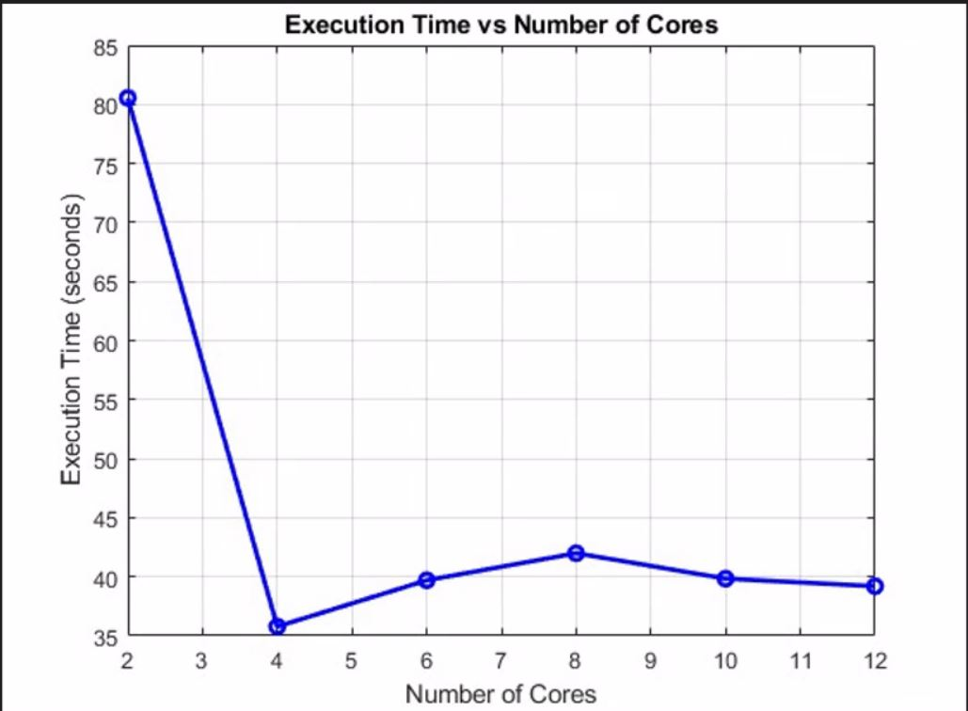

Visualization Output obtained showing Execution times on each core in above graph

**ANALYSIS OF CORE COUNTS**

* **2 Cores**: The execution time of **80.5493 seconds** demonstrates the baseline performance for the genetic algorithm running on a dual-core setup. While offering parallel processing, the overhead or potential resource limitations might have impacted its efficiency.

* **4 Cores**: With an execution time of **35.7826 seconds**, the algorithm showcases substantial improvement in efficiency compared to the 2-core setup. The increased speedup and efficiency indicate effective utilization of resources.
* **6 Cores**: Execution time slightly increased to **39.7006 seconds**, deviating from the expected linear reduction in execution time. This observation suggests the presence of overhead or system constraints impacting the algorithm's efficiency.
* **8 Cores**: Further scaling to 8 cores resulted in an execution time of **41.9951 seconds**. The efficiency dropped, indicating diminishing returns per additional core, likely due to increased overhead.
* **10 Cores**: The execution time remained similar to that of 6 cores at **39.8404 seconds**, with comparable efficiency, showcasing limitations in leveraging additional cores for speedup.
* **12 Cores**: Despite utilizing 12 cores, the execution time of **39.1971 seconds** remained consistent with the 10-core scenario. The efficiency continued to decrease, reflecting challenges in efficiently using the additional cores.

**Challenges in Utilizing Additional Cores:**

1. **Diminishing Returns**: The execution times don't consistently decrease with an increase in core count. For instance, moving from 4 to 6 cores shows a slight increase in execution time (35.7826 to 39.7006 seconds). This suggests diminishing returns per additional core, indicating challenges in efficiently utilizing these additional resources.

2. **Consistent Execution Time**: The execution time doesn't significantly decrease after a certain point (between 6 to 12 cores). Despite using more cores, the execution time remains relatively stable around 39 seconds, indicating limited efficiency gains beyond a certain core count.

**Potential Scope for Improvement:**

1. **Algorithm Optimization**: Review and optimize the Genetic Algorithm parameters for parallel execution. This includes adjusting population size, selection strategies, crossover, and mutation rates tailored specifically for parallel processing. Fine-tuning these parameters could potentially enhance efficiency across varying core counts.

2. **Load Balancing**: Ensure efficient load balancing among cores. Imbalances in task allocation across cores might lead to underutilization of certain cores while overloading others, impacting overall efficiency. Implementing better load-balancing strategies could improve resource utilization.

3. **Profiling and Debugging**: Conduct thorough profiling and debugging to identify and address bottlenecks or inefficiencies in the parallelized algorithm. Profiling tools can help pinpoint areas where computation is inefficient or where parallelization overhead is high.

4. **Parallelization Overhead**: Evaluate and minimize parallelization overhead. Overheads associated with parallelism, such as communication costs between processes or synchronization delays, might be impacting overall efficiency. Optimizing communication patterns and minimizing synchronization overhead could improve efficiency.

5. **Optimized Task Decomposition**: Assesses how tasks are decomposed and distributed among the cores. Fine-tuning the task decomposition strategy to match the nature of the problem and the available resources could lead to more efficient parallel execution.

6. **Parallel Framework Selection**: Explore alternative parallel computing frameworks or techniques. Depending on the nature of the problem and available resources, different parallelization approaches (e.g., different profiles, parallelization libraries, or frameworks) might yield better efficiency.

**ADVANTAGES OF PARALLELIZED GENETIC ALGORITHMS**

* **Faster Optimization:** Parallelized genetic algorithms can significantly speed up optimization tasks by distributing the computation workload across multiple processors or machines.
* **Improved Solution Quality & Convergence:** Parallelization allows for the exploration of a larger search space, increasing the chances of finding better quality solutions to optimization problems and improving convergence.
* **Scalability:** Parallelized genetic algorithms can easily scale to handle larger optimization problems by adding more processors or machines to the computation.

**CONCLUSION**

* In conclusion, the key points discussed highlight the potential of parallelized genetic algorithms in advancing optimization efficiency. By leveraging parallel processing capabilities, genetic algorithms can solve complex optimization problems faster and more effectively even large-scale problems that were previously infeasible.
* The demonstrated potential of parallelized Genetic Algorithms highlights their capacity to accelerate optimization tasks by harnessing parallel processing capabilities. It showcases the ability to explore multiple solutions concurrently, aiding in improved convergence and enhanced optimization outcomes.
* Optimization in algorithmic parameters, load balancing strategies, and minimizing parallelization overheads presents an avenue to maximize the efficiency of parallelized GAs across diverse core configurations.
* The parallelization of genetic algorithms allows for the exploration of multiple solutions simultaneously, enables the utilization of distributed computing resources leading to improved convergence and better optimization results of large-scale problems that were previously infeasible.
* In summary, Parallelized Genetic Algorithms possess transformative potential in addressing optimization problems more effectively. While challenges exist, their utilization of distributed computing resources and ability to tackle large-scale problems indicate a paradigm shift in optimization processes, offering scalability, efficiency, and enhanced solution quality.

**REFERENCES**

1. **BOOKS:**

* "Genetic Algorithms in Search, Optimization, and Machine Learning" by David E. Goldberg <http://www2.fiit.stuba.sk/~kvasnicka/Free%20books/Goldberg_Genetic_Algorithms_in_Search.pdf>
* "Parallel Programming: Techniques and Applications Using Networked Workstations and Parallel Computers" by Barry Wilkinson and Michael Allen <https://dl.icdst.org/pdfs/files3/6b0ed37cdf2cd9ce301f85f13182bb8b.pdf>
* "Introduction to the Theory of Computation" by Michael Sipser] <https://fuuu.be/polytech/INFOF408/Introduction-To-The-Theory-Of-Computation-Michael-Sipser.pdf>)

1. **Research Papers and Journals:**

# Intelligent Frequency Assignment Algorithm Based on Hybrid Genetic Algorithm

( <https://ieeexplore.ieee.org/document/9270430>) AND

* ACM Transactions on Parallel Computing: Found on the [ACM Digital Library] ( <https://dl.acm.org/doi/pdf/10.1145/3624975>)